www.club-808.com
Quick User Guide
April 1, 2011

- Home Page
- Register
- Log in
- User Profile
- View current posts
- View past posts
- Create a post
- Check event
  - Check event in Events Section
  - Check event through Event menu
  - Check event by Event Calendar
- Create an event
  - Reserve Tee Time
  - Check Event Reservation
- Check individual member handicap
- Post Golf Score
- Visit www.pbegolf.com
- Search

1. Home Page
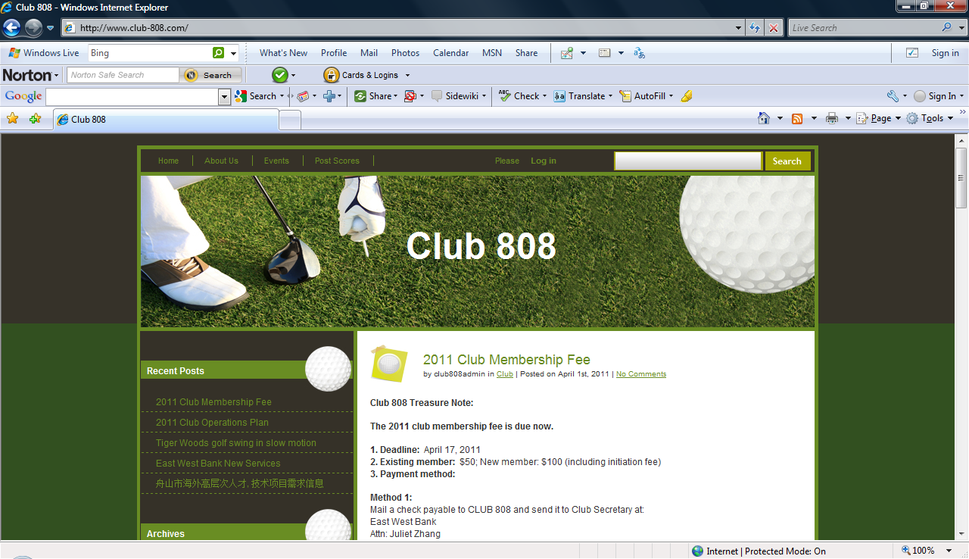
2. Register: You have to register to club 808 website first. Type your name and email (prefer your personal email). Then a password will be sent to your email.
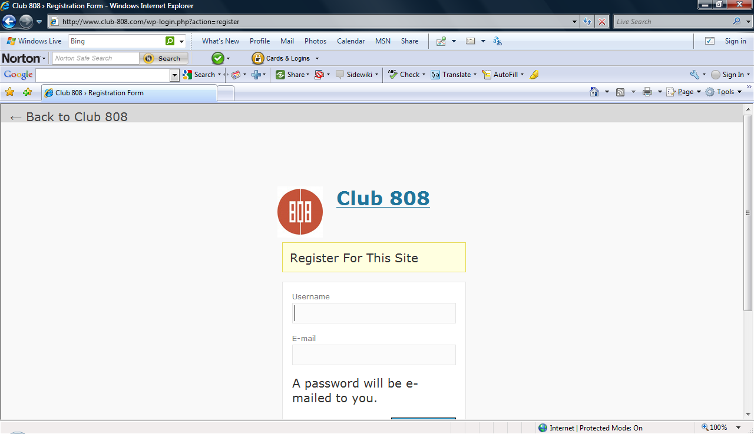
3. After register, you can use the website by logging in. There are two ways to log in:
Log in (method 1): Click “Log in” button in the center of menu bar
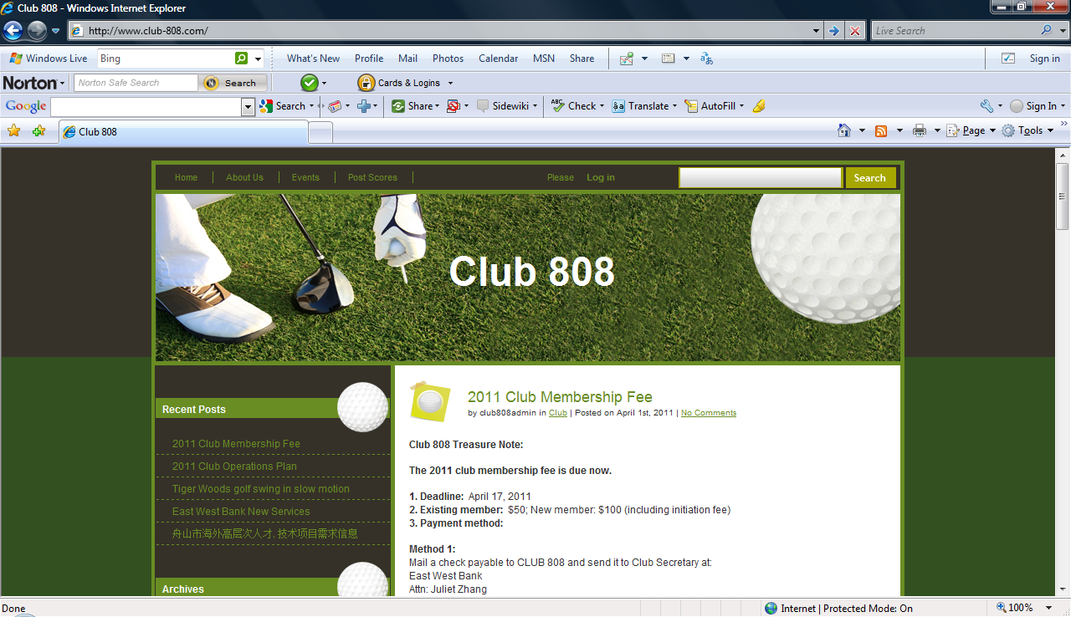
Log in (method 2): Click “Log in” button under Meta
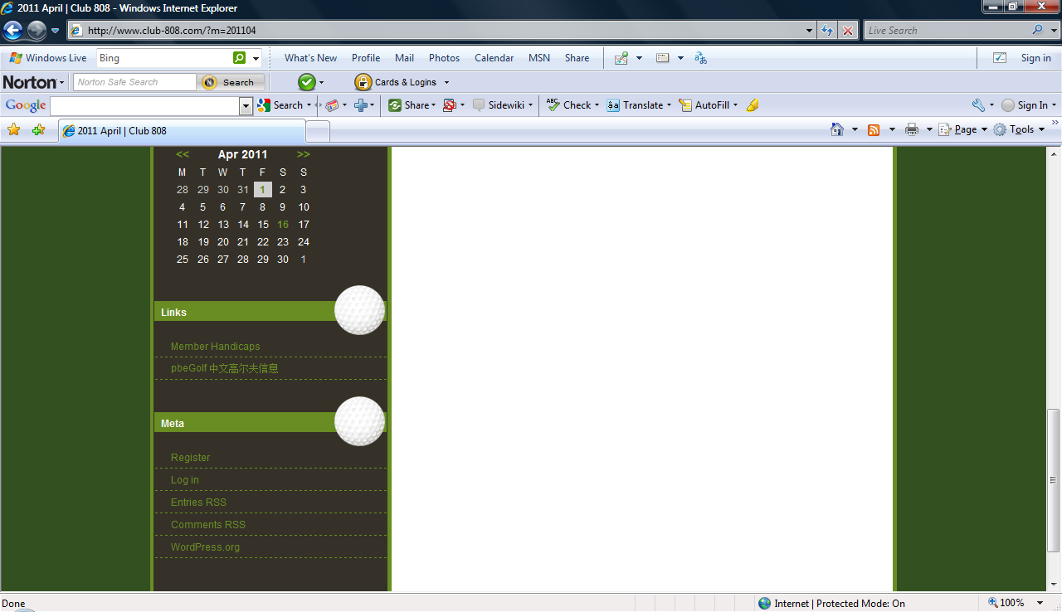
4. After you log in, you will be in Profile page, in which you have to fill out all required fields and other optional fields. Then you press Update Profile button.
Note: If the Profile page is not complete, your log in is not complete.
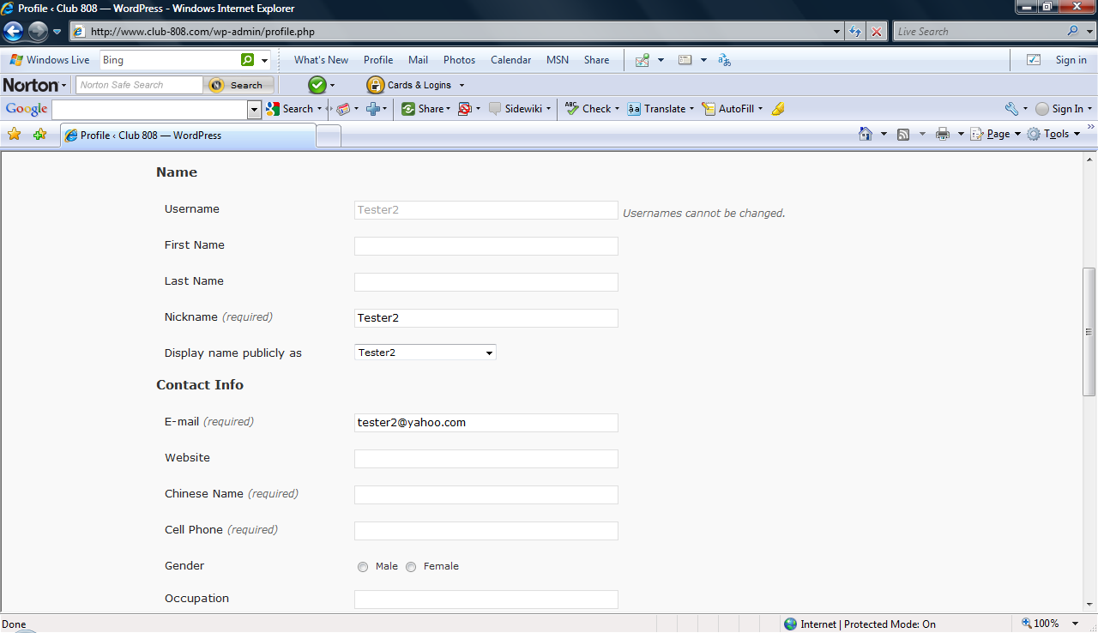
5. To view the current posts, go to Recent Posts and click the post you want to review.
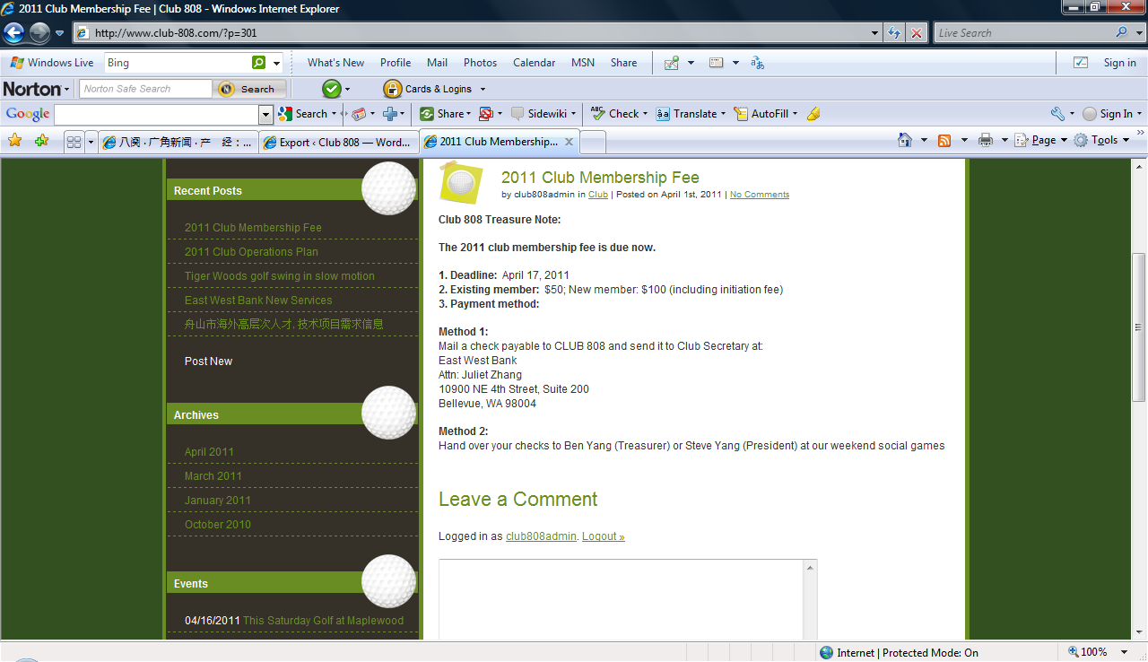
6. To view the past posts, go to Archives and select the month you want to review.
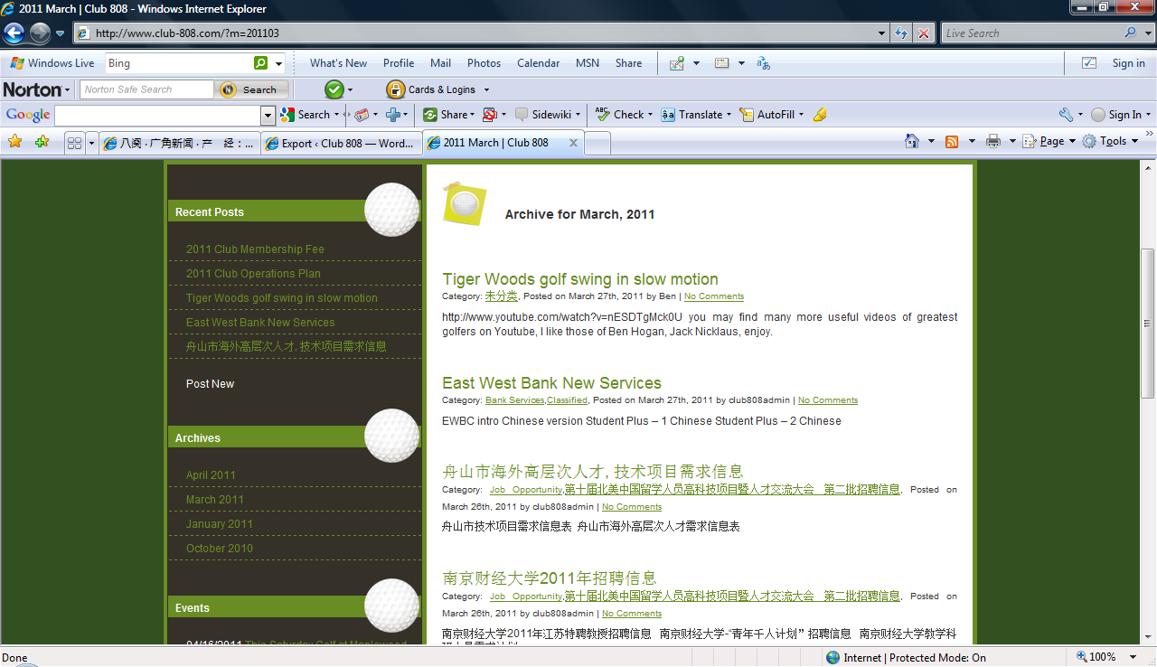
7. To create a post, press Post New button under Recent Posts
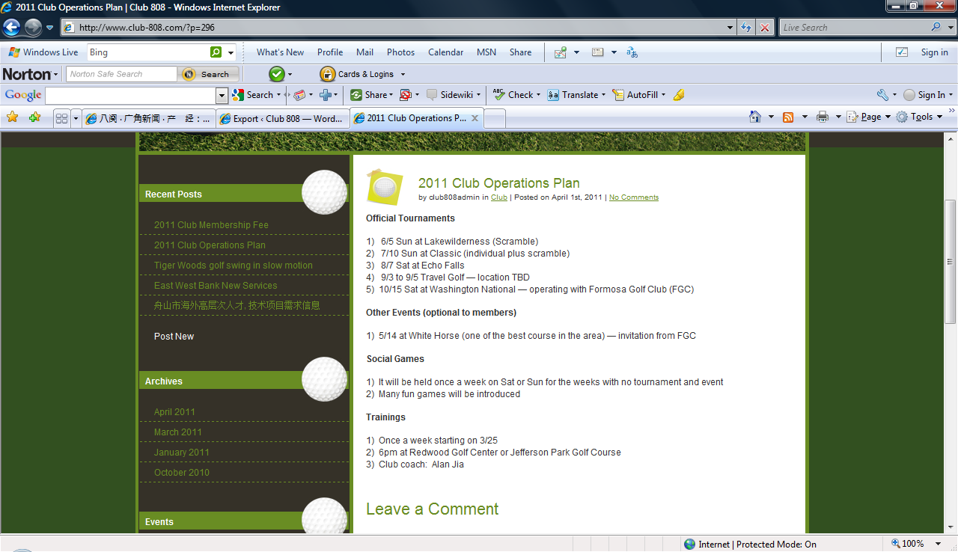

8. To check event,
8.1 Go to Events section and select the event you want to review.
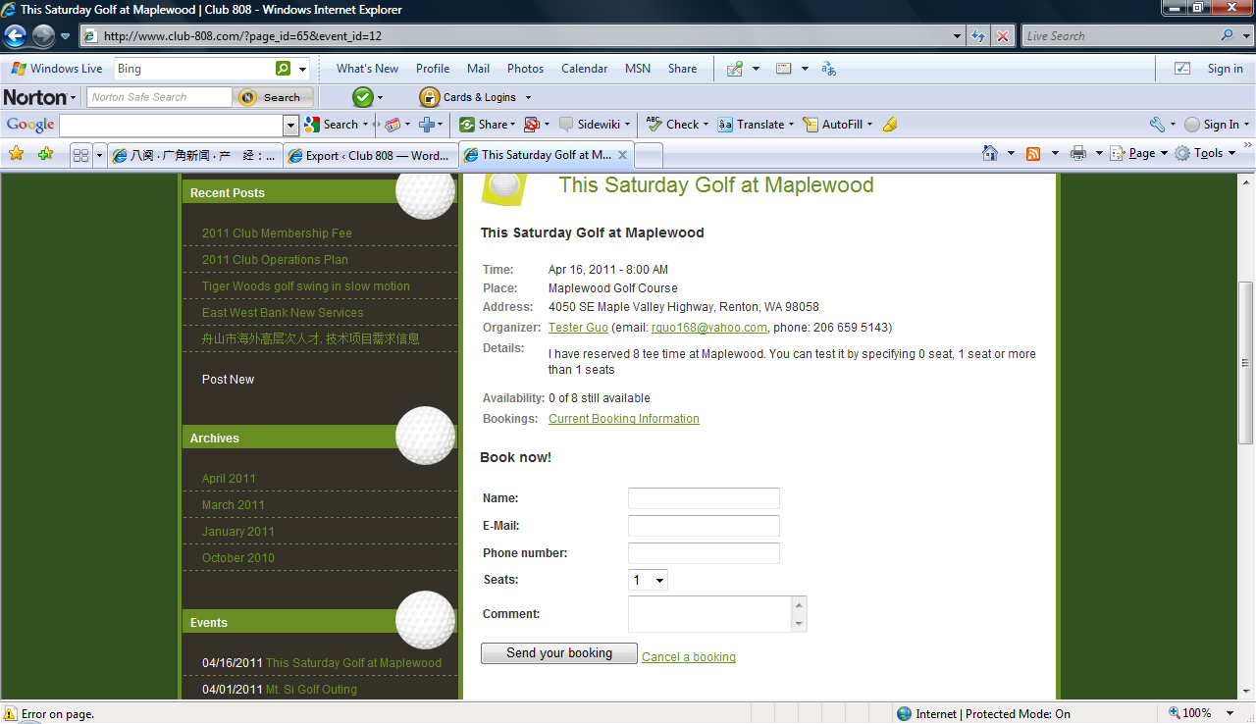
8.2 To check events, you may go to Event in the menu.
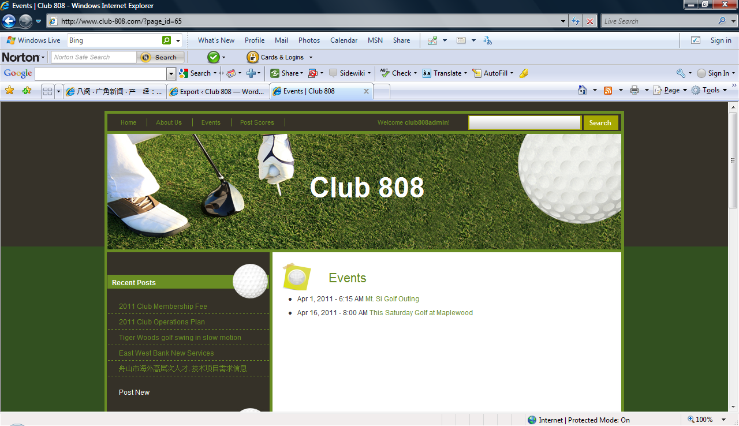
8.3 You can check events by looking at Event Calendar section. The date highlighted in green color will be the time that event will take place.

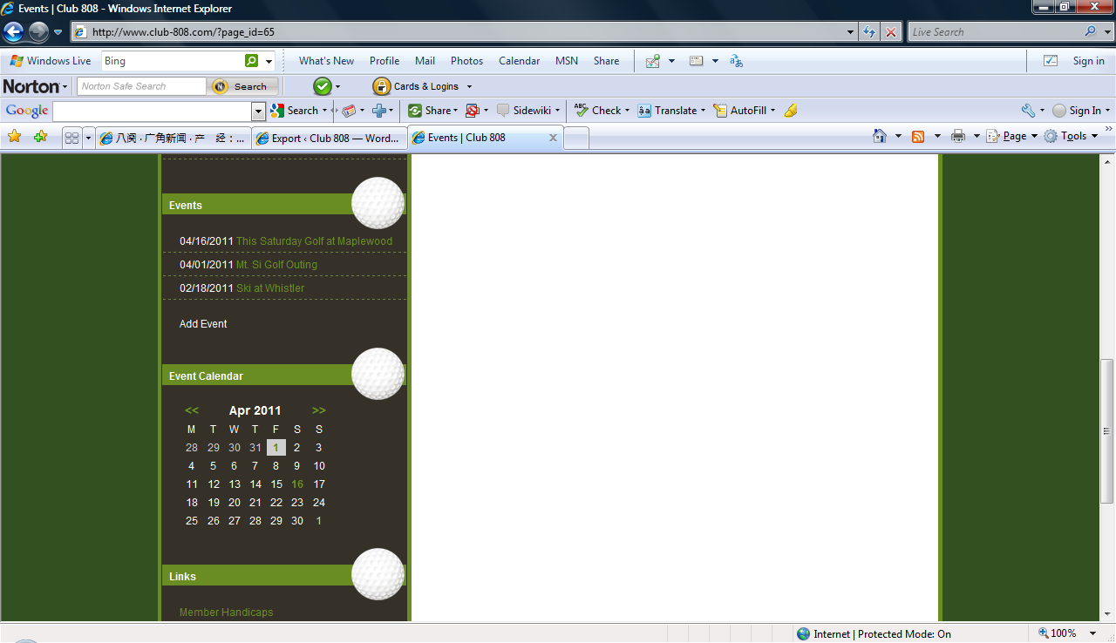
9. To create an event, such as scheduling a golf outing, go to Events section and press Add Event button.
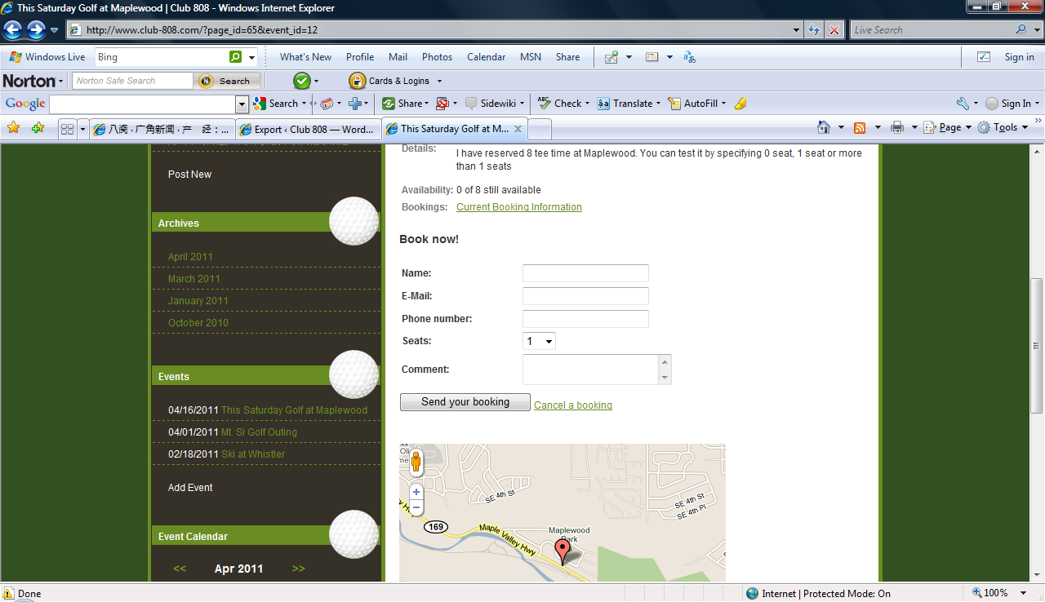
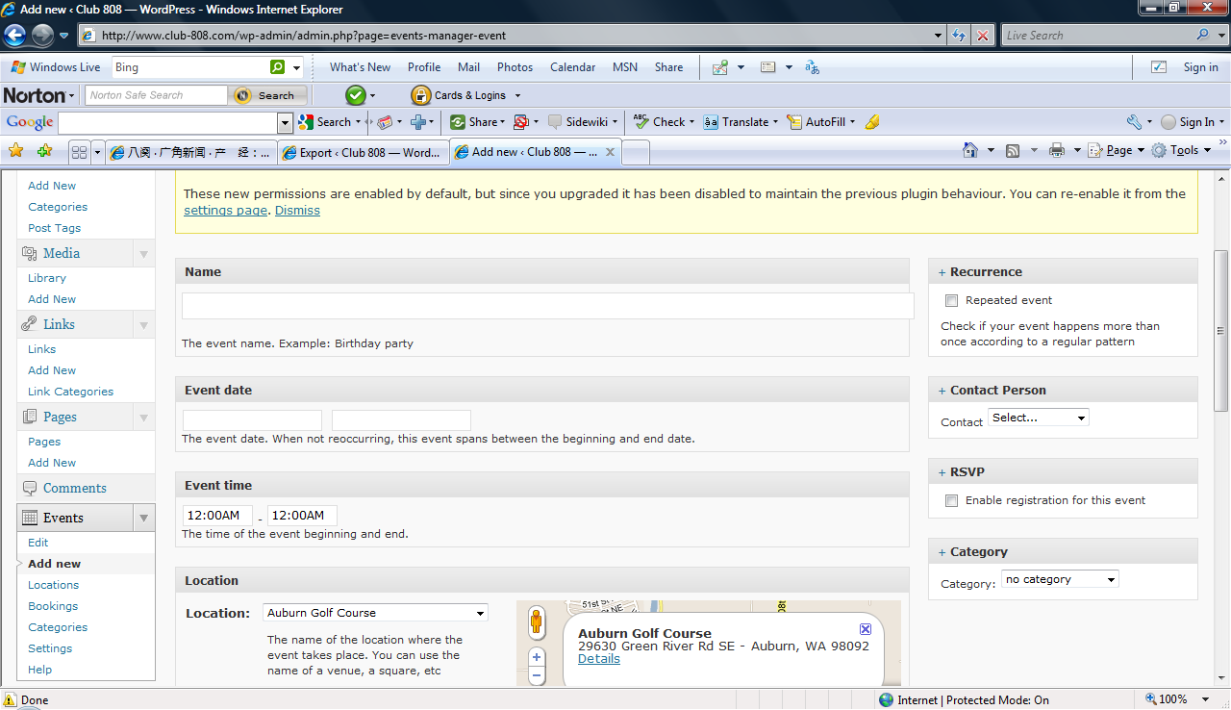
9.1 To reserve a tee time, go to the Event, under Book Now! Section, enter your name, email and phone and number of seats and/or comments, then press Send Your Booking button. Your request to reserve a tee time is complete.
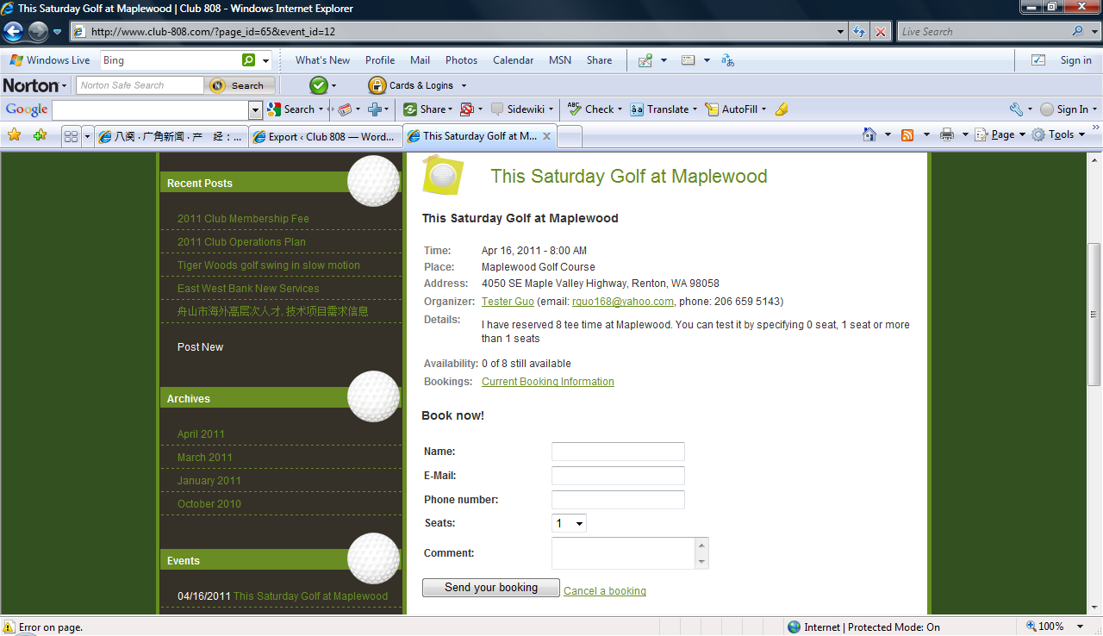

9.2 To check reservation status, press Check Booking Information in the Event
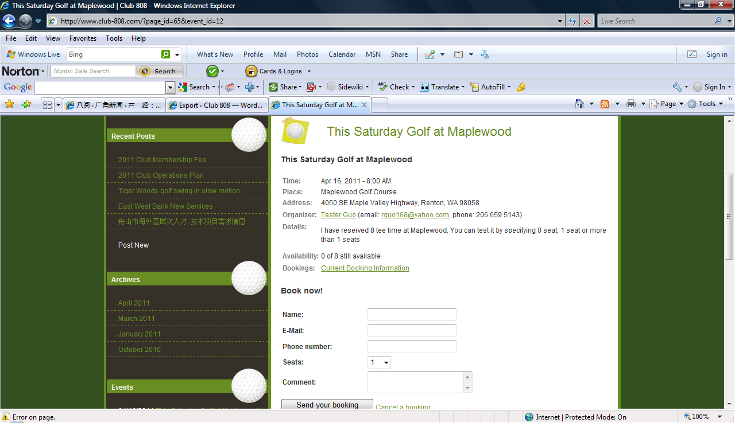
10. To check individual member handicap, go to Links section and press Member Handicaps
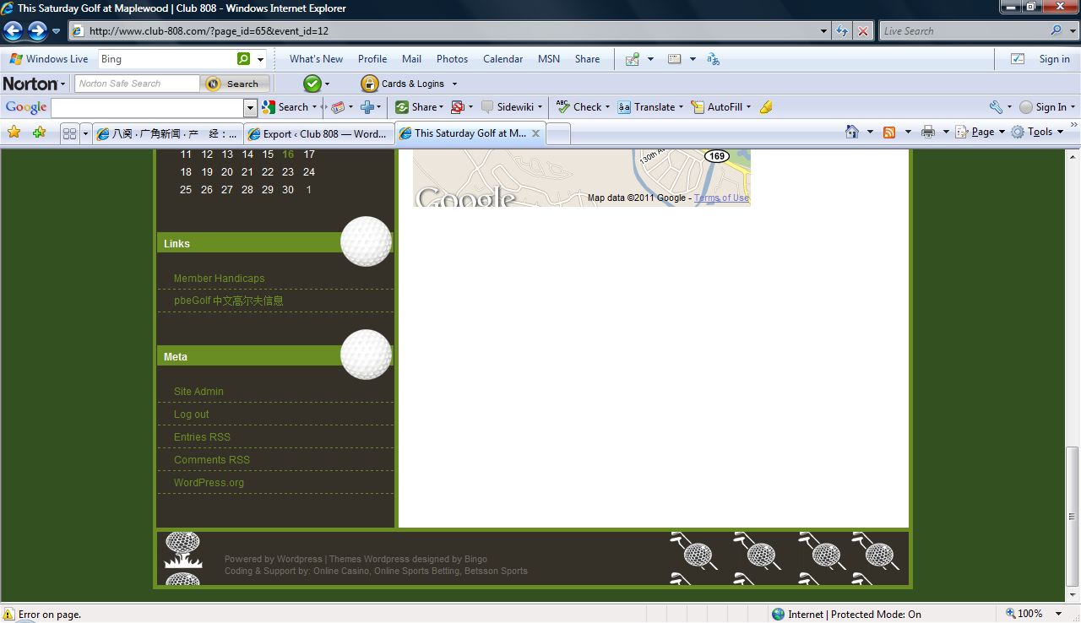

11. To post your golf score, go to Post Scores in the menu. ( This function is under construction)
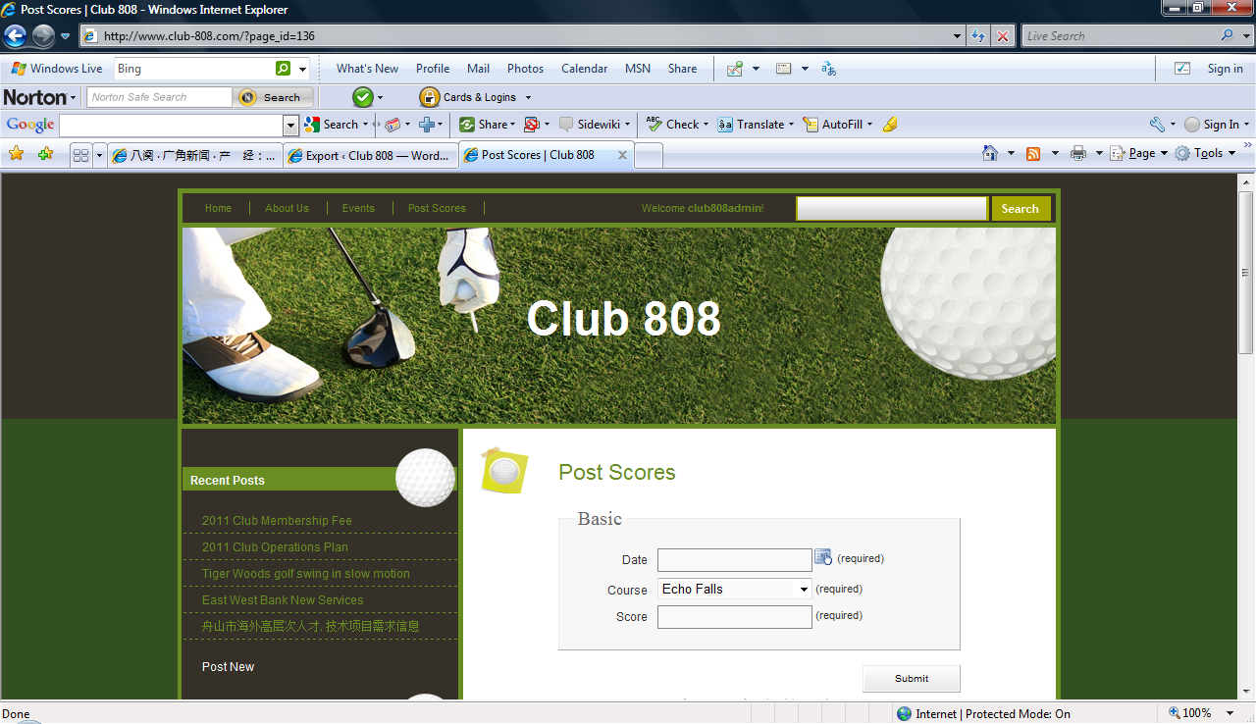
12.To go to www.pbegolf.com website, go to Links section and press pbeGolf button.
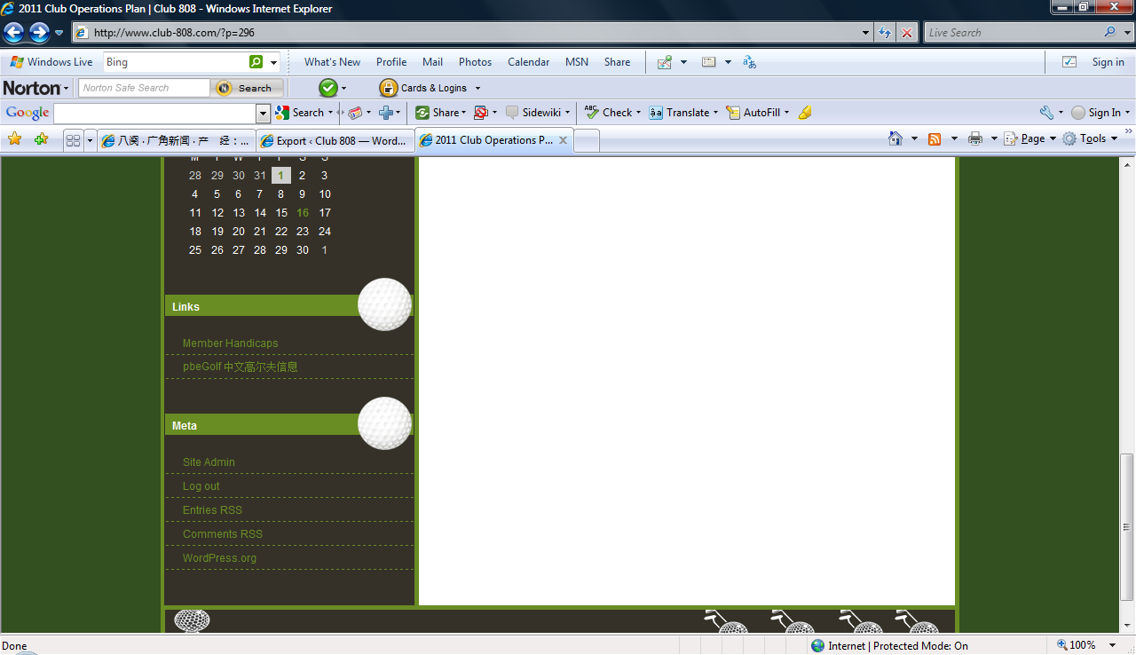
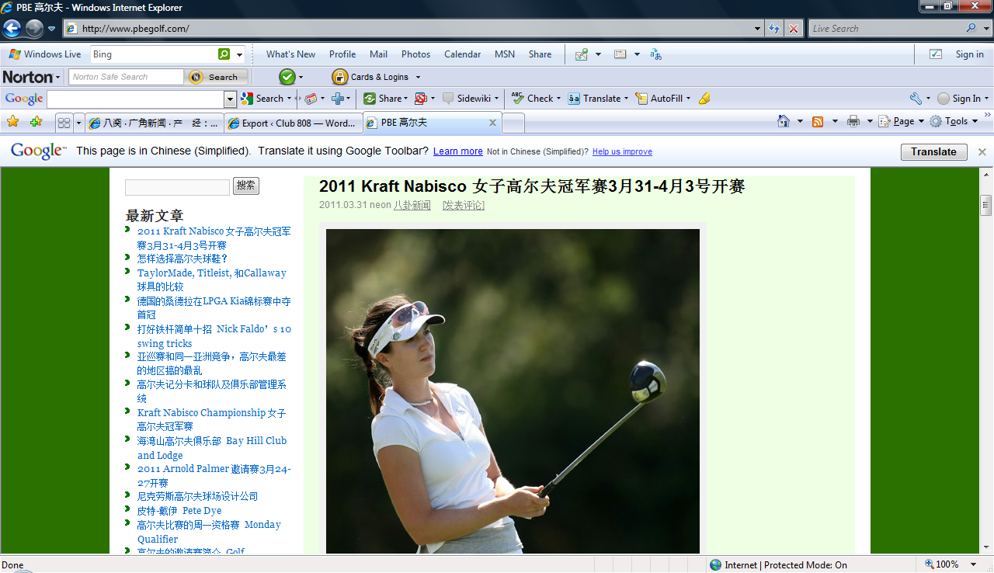
13. To search any subject you are interested, type the word in Search field and press Search button
